Lifting Notes for GTS600 Greenthaw Systems

Prerequisites
- Properly rated lifting equipment (crane or hoist). A fully loaded model GTS600 can in excess of 4 tons (4000kg).
- Machine stopped. Disconnect all electrical power and HTF circulation lines.
- All doors and access covers closed and secured.

WARNING
Crushing hazard. You may be crushed if the lifting devices fail.
- Never stand under, or get onto, the machine while it is being lifted or moved.
- Use only the designated lifting points to lift the machine.
- DO NOT use the eyelets at the top of the unit for lifting!
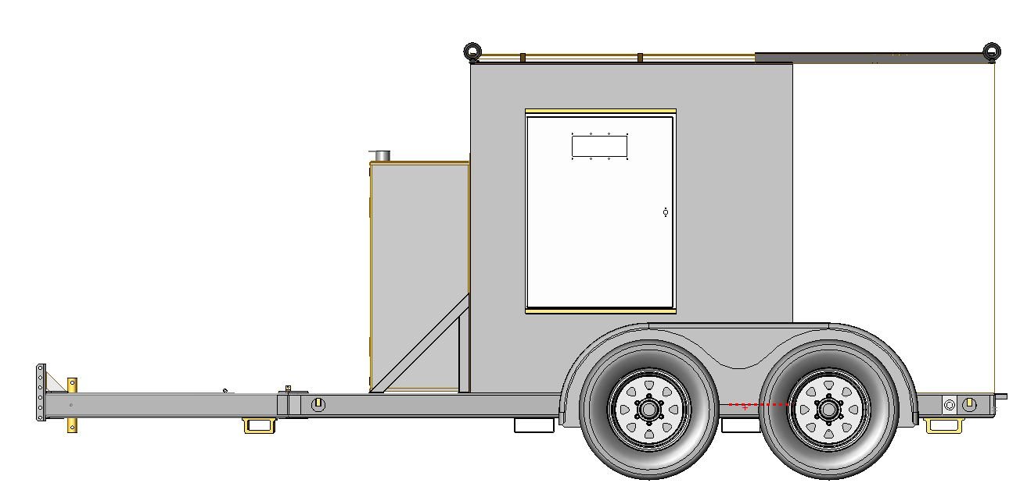

GTS600 Left (Driver’s) Side View
DO NOT use these eyelets

Lift Pockets

Procedure
Follow the procedure below to lift the machine.

1. Attach the lifting equipment through both of the lift pockets on the machine using
Slings or other appropriate lifting devices.

2. Lift the machine a small distance.

WARNING
Crushing hazard. An unstable machine may cause the lifting devices to fail. You
may be crushed if the lifting devices fail.
- Check for stability before continuing.

3. Check for stability. If necessary, lower the machine, reposition the lifting device and/or adjust weight distribution of the unit, and lift the machine a small distance again.

Note
Weight distribution within the unit is variable depending on loadout. Quantity of onboard fuel, circulation hose, and the presence of a generator will affect the centre of mass of the unit. It is critical that the machine be lifted in a stable fashion. Ballasting may be used to level the load.

4. Continue lifting the machine as necessary.

